***Web Programming(CSE211),Fall semester 2024\2025***

**Assignment #1:Website conceptual design and mock-up**

**Name: ziad rashad saeed**

**ID:222100664**

**Part one: Research**

**l- The defining characteristics of Web 2.0 to Web 4.0**

Whereas Web 2.0 focused on interactive, user-generated content with heavy emphasis on social media and collaboration, Web 3.0, the Semantic Web, is harnessed by machine-readable data and personalization through AI for an enhanced user experience. Web 4.0, also called the "Intelligent Web," will be completely integrated into an AI-driven environment, wherein digital interactions will predictively meet user needs without intervention across various connected devices.

**2- What are the key features of Web 2.0 and how it empowers the power of networks.**

It is characterized by interaction web platforms, social networking, user-generated content, and collaboration. It gives network power in the function of enabling users to share with huge numbers, connect, and create content, fostering innovation and information exchange driven by communities. The interaction then transforms the role of users from that of passive consumption to active participants, thereby increasing value and reach in digital networks.

**3- What are the key features of Web 3.0 and how it empowers the meaning of data and knowledge connections.**

Web 3.0 is also referred to as the Semantic Web, which places great emphasis on intelligence in data interpretation, AI, and decentralization. The major characteristics are linked data, semantic analysis, and personalization that empower meaning to data by making machines contextual understanders. This develops a network of richer knowledge because of the interconnectivity between data across different platforms, and it provides more relevant and insightful user experiences.

**4- What are the key features of Web 4.0 and how it empowers the intelligence connections.**

The "Intelligent Web," also known as Web 4.0, is a stage that incorporates AI, and higher states of machine learning toward frictionless, anticipatory interaction. Main characteristics include real-time processing of data, connected smart devices, and hyper personalization. Web 4.0 leverages AI-driven insight for intelligent connectivity; systems will predict user needs and then react to them, thus creating intuitive and context-sensitive digital environments on device classes.

**5-The importance of collective intelligence, social networking, social media and social bookmarking.**

Collective intelligence allows gathering knowledge from various sources, thus considerably enhancing problem-solving and innovation. Social networking and social media facilitate contact among people and allow for the sharing of information and cooperation in real time. Social bookmarking supports the organization of web resources collectively-that is, valuable content is easily accessible. Jointly used, these tools help multiply insights, channel community-driven knowledge, and democratize information by driving better-informed and more collaborative digital communities.

**6- How these technologies empower the current and future business plans.**

These technologies facilitate smarter ways of doing business through real-time insights, customer engagement, and knowledge sharing. The collective intelligence spurs innovation, while social networking and media will provide consumer feedback directly and brand visibility. Social bookmarking is useful for resource organization. In fact, all these put together enable enterprises to adapt, personalize offerings, and stay ahead of market trends while devising agile data-driven plans for sustainable growth.

**7-How do you intend to use the latest technologies in your profession?**

I can only hope to be able to provide my services with the most complete correctness, relevance, and speed by letting AI do the work in contextual dialogue-through NLP passed natural conversational tone, while machine learning was used for responsiveness. I'm able to give current guidance because of data analysis and access to information in real-time. Continuous learning also allows me to keep up to speed with the latest trends, hence providing innovative, individualized support to customers.

**Part Two:Web site planning**

**Define the purpose of the gym intended website.**

The purpose of the gym website is to attract new members, engage current members, and showcase the gym's unique offerings. It clearly conveys information on membership options, class schedules, and training services in a way that can easily support creating an online booking. Furthermore, this website will enable consistency in sharing tips on fitness, success stories, and updates to evidence its strong presence and community online.

**What would you like the gym website to accomplish?**

The gym website aims to attract new members, provide essential information on memberships and classes, facilitate online bookings, and engage current members through updates and success stories. It will showcase trainer expertise and offer fitness tips, enhancing user experience with a user-friendly interface. Ultimately, the website seeks to support member retention and promote a healthy lifestyle.

**Who is your intended audience for the gym website?**

The website for the gym is for potential members in search of options in keeping fit, current members wanting to obtain updates and resources, professionals in the field of fitness who would want to showcase expertise, enthusiasts in health looking for tips, and families looking for family-friendly programs. Such a diverse audience enables the website to promote offerings well and build a community that supports one's journey of fitness.

**What opportunities, problems, or issues does your planned gym website address?**

**Opportunities**

More visibility: Make an online presence prominent, increasing the joining rate of new members by assured marketing and SEO.

Better Engagement : It allows people to interact with one another, therefore creating a community.

Convenient care: like online booking and scheduling, helps members manage their fitness regimen with much less hassle.

**What kind of content could be incorporated on your gym website?**

Class Schedules: The latest in fitness classes on offer.

Membership Information: Plans, pricing, and related benefits.

Trainer Profiles: Bios and qualifications of the trainers themselves.

Success Stories: Testimonials and stories of transformations.

Fitness Tips and Articles: Blog postings related to workouts and nutrition.

Videos: Instructional videos, or even virtual tours around the gym.

Frequently Asked Questions: Answers to some common questions on services.

Events and Workshops: Details of upcoming events.

Online Booking: Web-based class and session booking system.

Community Forum: A place where members can interact and discuss things with each other.

**How will the site serve the client?**

It would serve clients by creating an easily accessible source of information about classes and memberships, online booking for sessions and workshops, and a way to connect through success stories and forums. The motivation will come through fitness resources, whereby clients can even create personalized profiles to track their progress, and real announcements of everything keep the clients informed, thus enhancing the overall satisfaction and engagement of the clients.

**What’s the best method for the user to do what’s wanted?**

How the users of the gym website can achieve their goals best includes:

Ease of navigation: Easy menus leading to information.

Search functionality: A search box where users can find information in the shortest time possible.

Online booking system: An easy interface where users can book classes and training sessions.

Personal account management: Profiles through which their progress can be tracked, and bookings managed.

Responsive design: Optimized for mobile phones, providing access anywhere.

Interactive content: A bit of other multimedia content like videos or forums.

FAQs and Support: A well-documented FAQ section, with customer support available.

**How will users find the function?**

Users will access the functionalities provided by the website of the gym through:

Clearly Structured Menu: Categorized menu actions which enable easy navigation.

Conspicuous Search Box: It shall be an easily viewable search box to access information directly.

Emphasized Call-to-Action Buttons: Noticeable buttons for bookings or joining.

Engaging Homepage: The interactive elements that may help users not get bored by exploring the service.

User Onboarding: Guided tours showing them the important features.

Mobile Responsive Design: Functions are easily accessible both on smartphones and tablets.

**How will users find the function and how to receive it?**

These services can be facilitated on the website through the incorporation of intuitive navigation and clear menu categories that will assist users in quickly accessing services. This can also be aided through the implementation of a search bar, which enables users to retrieve information in a quick manner and promotes services in a more direct approach. Inclusion of eye-catching call-to-action buttons will draw users' attention towards each important action. Virtual tour-Assist in showing interactively how services are consumed. User accounts: it allows users to manage their bookings and progress within the facility. This shall be guided through the use of FAQs and customer support.

E-mail and Notifications: Class updates and promotions.

**What will the receiver do with the received entries and How will the receiver deal with results?**

workflows

Access Information: Review class information and memberships.

Decide: Choose classes to take or a membership type one wants to subscribe to.

Class Booking / Session Booking: Book online

Progress tracking: log exercise information on personal profiles

Content consumption: Reading articles, watching videos, posting in forums

Manage Outcome

Feedback System: Give feedback about taken class

Modify goals: Update fitness goals according to their perception.

Find support: Reach out to trainers or support staff for advice.

Join the Community: Share with members for motivation.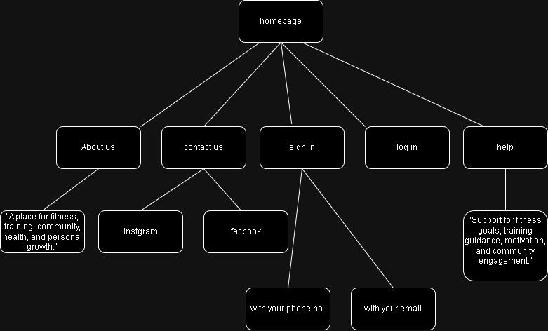

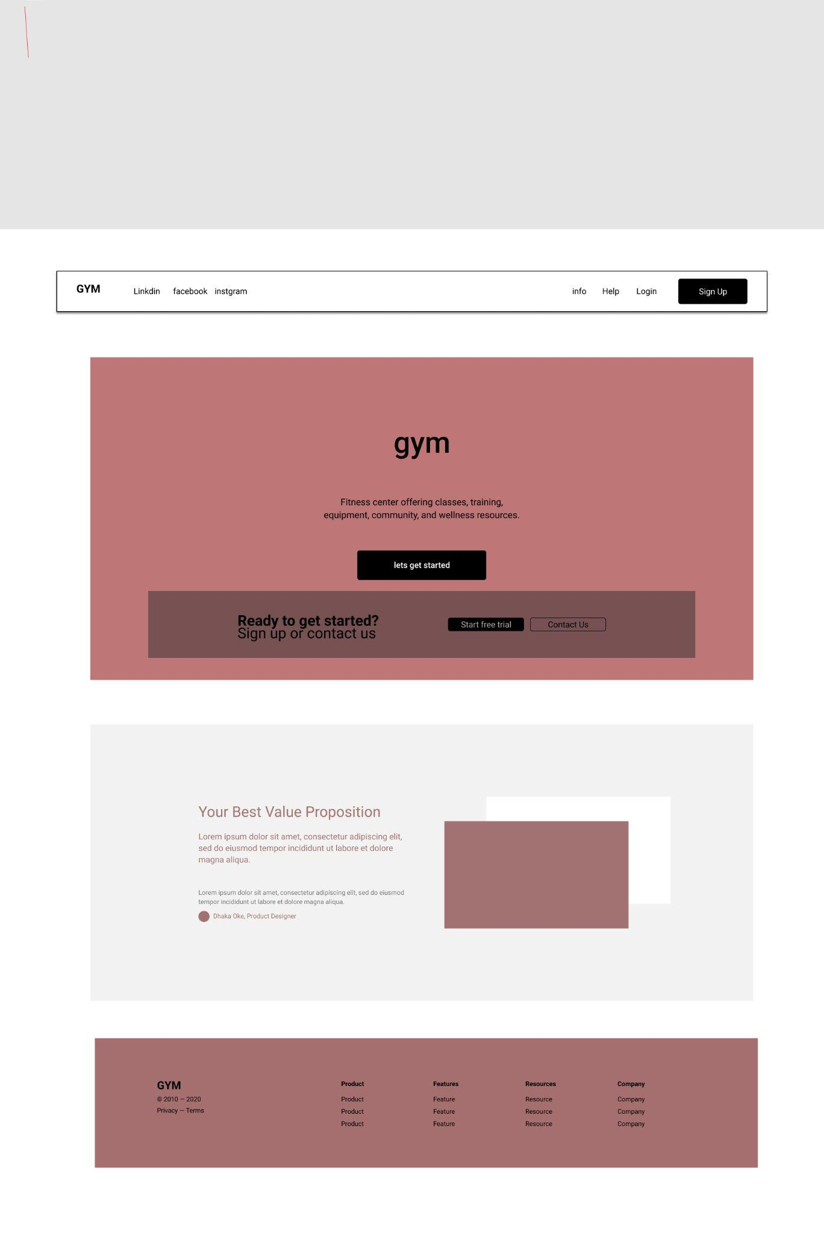

**REFERENCE:**

**Figma**

**Draw.io**

**adobe**